|  |  |  |  |  |  |  |  |  |
| --- | --- | --- | --- | --- | --- | --- | --- | --- |
|  | |  |  | | --- | --- | | **Maths (9-1)**  Y10 Higher Calculator APRIL 2025 | **C:\assets\img\ocr_design\cover_logo_new.png** | | Please note that you may see slight differences between this paper and the original.  Candidates answer on the Question paper.  **OCR supplied materials:** Additional resources may be supplied with this paper.  **Other materials required:** •   Pencil •   Ruler (cm/mm) | ****  **Duration:** 60 mins | |  | | |  |

|  |  |  |  |
| --- | --- | --- | --- |
| Candidate forename |  | Candidate surname |  |

|  |  |
| --- | --- |
| Teacher Name |  |

## INSTRUCTIONS TO CANDIDATES

•   Write your name, centre number and candidate number in the boxes above. Please write clearly and in capital letters.  
•   Use black ink. HB pencil may be used for graphs and diagrams only.  
•   Answer **all** the questions, unless your teacher tells you otherwise.  
•   Read each question carefully. Make sure you know what you have to do before starting your answer.  
•   Where space is provided below the question, please write your answer there.  
•   You may use additional paper, or a specific Answer sheet if one is provided, but you must clearly show your candidate number, centre number  
    and question number(s).

## INFORMATION FOR CANDIDATES

•   The quality of written communication is assessed in questions marked with either a pencil or an asterisk. In History and Geography   
    a *Quality of extended response* question is marked with an asterisk, while a pencil is used for questions in which *Spelling, punctuation and  
    grammar and the use of specialist terminology* is assessed.  
•   The number of marks is given in brackets **[ ]** at the end of each question or part question.  
•   The total number of marks for this paper is **59.**  
•   The total number of marks may take into account some 'either/or' question choices.

**1.**    
  
Simplify.

1. a6 ÷ a2

|  |  |  |  |
| --- | --- | --- | --- |
| **(i)** |  |  | **[1]** |

1. (b5)3

|  |  |  |  |
| --- | --- | --- | --- |
| **(ii)** |  |  | **[1]** |

**2.**    
  
Simplify.

|  |  |
| --- | --- |
|  | C:\core\files\questions\1528825793\J560-Maths-J560-06-Jun17\img\pg18_Q_01_150.png |

|  |  |
| --- | --- |
|  | ......................................... **[1]** |

**3.**    
  
Calculate the volume of a sphere with radius 6 cm.



C:\core\files\questions\adminupload\154729\pg12_Q_02a_150.png

[The volume V of a sphere with radius r is ]

|  |  |  |
| --- | --- | --- |
|  |  | cm2  **[2]** |

**4.** The diagram shows an arc of a circle inside a square of side 6cm.

Work out the shaded area.

..................................................... cm2 **[4]**

C:\core\files\questions\1592273840\J560-Maths-J560-04-Nov19\img\pg03_Q_01_150.png

**5.** Use the formula to find the value of F when

|  |  |  |
| --- | --- | --- |
|  | s = 5.8 × 106 |  |
|  | t = 4.1 × 108 |  |
|  | m = 3.7 × 10-2. |  |

Give your answer in standard form, correct to 2 significant figures.

|  |
| --- |
| ........................................................... **[4]** |

**6.** 3(2x + d) + c(x + 5) = 10x + 17  
  
Work out the value of c and the value of d.

c …………………………………………… d ……………………………………………...**[5]**

**7.** i. Sketch a graph on the axes below that shows that y is directly proportional to x.



**[2]**

ii. Sketch a graph on the axes below that shows y = x 3.



**[2]**

**8.** P has coordinates (0, −1) and Q has coordinates (4, 1).

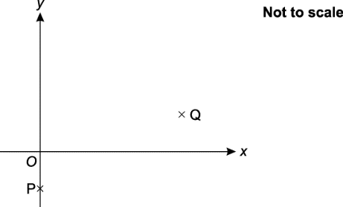

Find the equation of line PQ.

 ..................................................... **[3]**

**9(a).** 72 children are asked whether they have a laptop or an iPad.

|  |  |
| --- | --- |
| • | 31 have a laptop. |
| • | 48 have an iPad. |
| • | 12 have both. |
| • | 5 have neither. |

Represent this information on a Venn diagram.



|  |
| --- |
| **[3]** |

**(b).** One of the children is chosen at random.  
  
Write down the probability that they have an iPad but not a laptop.

|  |  |  |
| --- | --- | --- |
|  |  | **[2]** |

**10.** Here is a right-angled triangle.

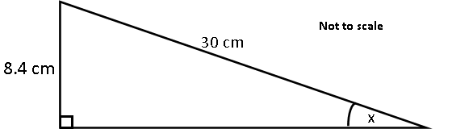

Work out the value of x.

|  |  |  |  |
| --- | --- | --- | --- |
|  | x = |  | **[3]** |

**11.** The probability that any postcard posted in Portugal on Monday is delivered to the UK within a week is **0.62**.  
The probability that any postcard posted in Portugal on Friday is delivered to the UK within a week is **0.41.**  
  
Sergio is in Portugal.  
He posts one postcard to the UK on Monday.  
He posts another postcard to the UK on Friday.

1. Complete the probability tree to show the possible outcomes for the postcards.

|  |
| --- |
| C:\core\files\questions\adminupload\167387\pg09_Q_01_150.png |
| **[2]** |

1. Calculate the probability that only one of Sergio’s postcards is delivered within a week.

|  |  |  |
| --- | --- | --- |
|  |  | **[3]** |

**12.** A shop has a sale that offers 20% off all prices.  
 On the final day they reduce all sale prices by 25%.  
 Alex buys a hairdryer on the final day.  
   
 Work out the **overall** percentage reduction on the price of the hairdryer.

.......................... % **[6]**

**13(a).** An alloy is made from **28 cm3** of copper and **41 cm3** of gold.  
  
The density of copper is **9 g/cm3.**  
The density of gold is **19 g/cm3.**  
  
Work out the mass of copper used.

........................................................... g **[2]**

**(b).** Work out the density of the alloy.

........................................................... g/cm3 **[4]**

**14.** The diagram shows two triangles.

Prove that triangle ABC is congruent to triangle ACD

**[4]**

**15.** Two cylinders, A and B, are mathematically similar.  
  
Cylinder A has volume 2400 cm3 and height 12 cm.  
Cylinder B has volume 750 cm3.  
  
Find the height of cylinder B.  
Give your answer correct to an appropriate degree of accuracy.

|  |  |  |
| --- | --- | --- |
|  |  | cm **[5]** |

**END OF QUESTION PAPER**