|  |  |  |  |  |  |  |  |  |
| --- | --- | --- | --- | --- | --- | --- | --- | --- |
|  | |  |  | | --- | --- | | **Maths (9-1)**  Y10 Higher NON-Calculator APRIL 2025 | **C:\assets\img\ocr_design\cover_logo_new.png** | | Candidates answer on the Question paper.  **Other materials required:** •   Pencil •   Ruler (cm/mm)  Tracing paper | ****  **Duration:** 60 mins | |  | | |  |

|  |  |  |  |
| --- | --- | --- | --- |
| **Candidate forename** |  | **Candidate surname** |  |

|  |  |
| --- | --- |
| Teacher Name |  |

## INSTRUCTIONS TO CANDIDATES

•   Write your name, centre number and candidate number in the boxes above. Please write clearly and in capital letters.  
•   Use black ink. HB pencil may be used for graphs and diagrams only.  
•   Answer **all** the questions, unless your teacher tells you otherwise.  
•   Read each question carefully. Make sure you know what you have to do before starting your answer.  
•   Where space is provided below the question, please write your answer there.  
•   You may use additional paper, or a specific Answer sheet if one is provided, but you must clearly show your candidate number, centre number  
    and question number(s).

## INFORMATION FOR CANDIDATES

•   The quality of written communication is assessed in questions marked with either a pencil or an asterisk. In History and Geography   
    a *Quality of extended response* question is marked with an asterisk, while a pencil is used for questions in which *Spelling, punctuation and  
    grammar and the use of specialist terminology* is assessed.  
•   The number of marks is given in brackets **[ ]** at the end of each question or part question.  
•   The total number of marks for this paper is **60**.  
•   The total number of marks may take into account some 'either/or' question choices.

**1.**    
  
Rearrange the equation to make x the subject.

|  |  |
| --- | --- |
|  | y = 7x − 3 |

|  |  |
| --- | --- |
|  | x = ........................................................... **[2]** |

**2.**

1. Factorise completely.

5x2 + 15xy

**(i)..........................................**

**[2]**

1. Factorise.

x2 − 49

**(ii)..........................................**

**[1]**

**3.** Solve by factorising.

|  |  |  |
| --- | --- | --- |
|  | x2 + 9x + 20 = 0 |  |

|  |
| --- |
| x = .................... or x = .................... **[3]** |

**4.**    
  
Write the next term in each of these sequences.



|  |  |  |  |  |  |  |  |
| --- | --- | --- | --- | --- | --- | --- | --- |
| |  |  |  |  |  |  | | --- | --- | --- | --- | --- | --- | | 1 | 1 | 2 | 3 | 5 | 8 | |  |

|  |  |  |  |
| --- | --- | --- | --- |
|  | **(i)** |  | **[1]** |

 ii.

|  |  |  |  |  |  |  |  |
| --- | --- | --- | --- | --- | --- | --- | --- |
| |  |  |  |  |  |  | | --- | --- | --- | --- | --- | --- | | 2 | 4 | 8 | 16 | 32 | 64 | |  |

|  |  |  |  |
| --- | --- | --- | --- |
|  | **(ii)** |  | **[1]** |

**5.** You may use this coordinate grid to help you answer the following questions.

|  |
| --- |
|  |

Describe fully the **single** transformation that is equivalent to  
  
a reflection in the line y = x followed by a rotation of 90° clockwise around (0, 0).

**[3]**

**6.**    
  
The scale drawing represents a park.  
**Scale: 1 cm represents 25 m**



A new play area must be

* no more than 150 m from B
* closer to AD than to CD.

Construct and shade the region where the play area can be positioned.  
Show all your construction lines.

|  |  |
| --- | --- |
|  | **[5]** |

**7.**    
  
The owner of a tourist attraction records the amount of rainfall, in millimetres, and the number of visitors each day.  
The results for 10 days are shown in the scatter diagram.





|  |  |
| --- | --- |
| Circle the outlier on the scatter diagram. | **[1]** |

1. The owner claims that he would expect around 320 visitors on a day with 2 mm of rainfall.  
     
   Does the scatter diagram support his statement?  
   Explain how you made your decision.

**[2]**

1. Explain why the scatter diagram should not be used to estimate the number of visitors on a day with 9 mm of rainfall.

**[1]**

**8(a).** A triangle has vertices A, B and C.

|  |
| --- |
| C:\core\files\questions\1592208422\J560-Maths-J560-06-Nov19\img\pg18_Q_01_150.png |

The triangle is enlarged with scale factor f and centre of enlargement E.  
  
**Vertex A maps to (6, 7).  
Vertex B maps to (2, 9).**  
  
Find the coordinates of the centre of enlargement, E.

|  |
| --- |
| (............. , .............) **[2]** |

**(b).** Find the scale factor, f.

|  |
| --- |
| ................................ **[2]** |

**9(a).**

Rashid invests money into an account which pays a fixed rate of compound interest each year.

The value, £V, of his investment after t years is given by the formula

**V = 1250 × 1.03 t**

How much money did Rashid invest?

|  |
| --- |
| £ ........................................................... **[1]** |

**(b).** What rate of compound interest is paid each year?

|  |  |
| --- | --- |
|  | ...........................................................% **[1]** |

**10.**    
  
Work out.

|  |  |
| --- | --- |
|  | C:\core\files\questions\1551268843\J560-05-QP-Nov17\img\pg13_Q_002_150.png |

|  |  |  |  |
| --- | --- | --- | --- |
|  |  |  | **[3]** |

**11.**

C:\core\files\questions\1528805110\J560-Maths-J560-05-Jun17\img\pg08_Q_01a_150.pngC:\core\files\questions\1528805110\J560-Maths-J560-05-Jun17\img\pg08_Q_01_150.png

Vector Vector

On each grid below, draw a vector to represent

|  |  |  |  |
| --- | --- | --- | --- |
| **(i)** | **2a,** | **(ii)** | **a + b.** |
|  | C:\core\files\questions\adminupload\112018\pg08_Q_02a_150.png |  | C:\core\files\questions\adminupload\112018\pg08_Q_02a_150.png |

|  |  |
| --- | --- |
|  | **[2]** |

**12.**    
  
Work out.

5 × 104 − 1.6 × 103

Give your answer in standard form.

|  |  |  |  |
| --- | --- | --- | --- |
|  |  |  | **[3]** |

**13(a).** Triangles **P** and **Q** are right-angled.



|  |  |
| --- | --- |
| Show that the two shorter sides in triangle **P** have the same lengths as the two shorter sides in triangle **Q**. | **[3]** |

**(b).** Explain why the two triangles are congruent.

|  |
| --- |
| **[1]** |
|  |

**14(a).** The diagram shows two views of a solid made from 14 one-centimetre cubes.



On the centimetre grid below, draw a plan of the solid.

**[2]**

**(b).** Work out the **smallest** number of cubes that need to be added to the solid to make a cube.

........................................................... **[2]**

**15(a).** This box plot shows the distribution of students' percentage marks in a history test.

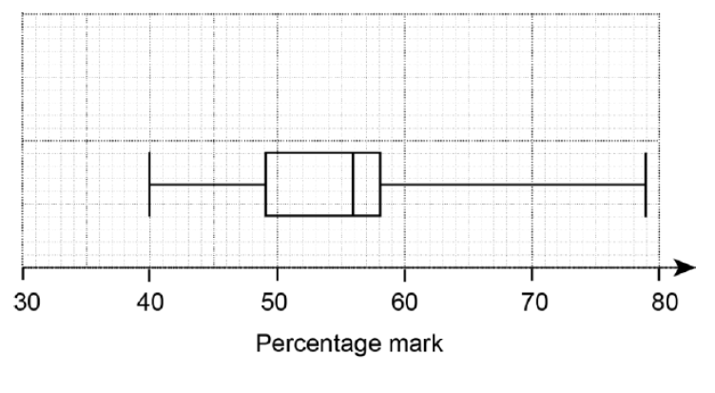

Use this box plot to find

1. the median,  
    **(i)** ..........................................% **[1]**
2. the interquartile range.

**(ii)** ..........................................% **[1]**

**(b).** The following statements are true for the students' percentage marks in a geography test.

* The median is 5% less than in history.
* The lower quartile is 46%.
* The interquartile range is 13%.
* The range is 45%.
* The lowest score is 35%.

Use these statements to draw the box plot for the distribution of the students' percentage marks in geography.



**[3]**

**(c).** Compare the distribution of the percentage marks in geography and the distribution of the percentage marks in history.

**[1]**

**16(a).** The cumulative frequency graph shows information about the marks scored by a group of 80 students in a test.



Find the interquartile range.

|  |  |  |  |
| --- | --- | --- | --- |
|  |  |  | **[2]** |

**(b).**

The ratio of the number of students passing the test compared to failing the test is **4 : 1**.  
Find the minimum mark needed to pass the test.

|  |  |  |  |
| --- | --- | --- | --- |
|  |  |  | **[3]** |

**17.**

The sketch shows part of a graph which has equation **y = ax2 + bx + c .**



Find the values of a, b and c.

|  |  |  |
| --- | --- | --- |
|  | a = ........................................................... |  |
|  | b = ........................................................... |  |
|  | c = ........................................................... | **[5]** |

**END OF QUESTION PAPER**